**Application Form – information for applicants**

Researcher Links Workshop

*Education leadership and policy in Azerbaijan and the UK:*

*building capacity for school improvement*

UK coordinator: Professor Howard Stevenson (University of Nottingham)

Azerbaijan coordinator: Dr Elza Samedova (Khazar University)

Discipline: Education (leadership, management and policy)

**Dates and venue: 25-28th March, 2014; Khazar University, Baku, Azerbaijan.**

The British Council has launched a new five-year programme to encourage international research collaboration between ambitious young researchers from the UK and eighteen countries around the world.

The programme, ‘British Council Researcher Links’ provides opportunities for early career researchers from the UK and internationally to interact, learn from each other and explore opportunities for building long-lasting research collaborations.

As part of this programme, a ‘call to action’ was issued in June 2013 for leading researchers to propose themes for bilateral workshops to be held in one of these countries which will bring together early career researchers to discuss their research and start to build international relationships.

Successful applicant organisations from the UK and add country name are now recruiting early career researchers and welcome applications to attend the above workshop.

The workshops will provide a unique opportunity for sharing research expertise and networking. During the workshops early career researchers will have the opportunity to present their research in the forms of a poster/short oral presentation and discuss this with established researchers from the UK and partner countries. There will be a focus on building up links for future collaborations and participants selected on the basis of their research potential and ability to build longer term links.

The British Council and will cover the costs related to the participation to the workshop, including: travel (both international and local), accommodation and meals. These costs include local visits included in the programme. Costs for the visa will be covered; however participants will be responsible for making all the necessary arrangements. Although this cost will not be covered by the British Council, participants are encouraged to purchase an adequate travel and medical insurance. The British Council accepts no responsibility for any problems which may occur when the participants are in-country.

**Workshop Aims and Outline:**

This workshop seeks to bring together world-leading researchers, early career researchers and locally-based policy-makers to share knowledge and understanding about the role of educational leadership in bringing about school level and system change/improvement.

The workshop will focus on developing capacity at two levels:

*Capacity building within schools systems* – sharing research about how capacity is developed within individual schools and within local schools systems. There will be a specific focus on understanding the relationship between school leadership and student outcomes.

*Capacity building in relation to knowledge production and exchange* – school improvement requires intellectual capital to support it. This workshop seeks to develop capacity building amongst the developing research community through a) engaging with the latest international research relating to school leadership and policy, and b) providing advice and support for the career development of ECRs.

The workshop will include keynote presentations from each of the lead academics. These will focus on recent thinking from both the UK and Azerbaijan, and also draw on wider international research. There will also be varied opportunities for debate and networking – with both a focus on substantive issues, and academic career development.

Local policy input will be provided by the Ministry of Education in Azerbaijan and there will be an opportunity to develop a deep understanding of current education policy issues in Azerbaijan at a key moment in the country’s development.

The programme will include school and cultural visits in Baku.

**Application and Deadline:**

The full application below must be completed and submitted by the **24th January 2014** to: Professor Howard Stevenson ([howard.stevenson@nottingham.ac.uk](mailto:howard.stevenson@nottingham.ac.uk)) for the UK applicants and to Raziya Isayeva ([Risayeva@khazar.org](mailto:Risayeva@khazar.org)) for Azerbaijani applicants - please place ‘Researcher Links Application’ in the title of the email.

**Eligibility Criteria:**

* Applications must be submitted using the Researcher Links application form
* Application must be submitted before the above deadline

Participants must be early career researchers: Early Career Researchers are defined as holding a PhD (or having equivalent research experience) – and having up to 10 years post-PhD research experience. They are equivalent to the ‘Recognised Researcher’ and sometimes ‘Experienced Researcher’ categories in the EU framework for researchers’ careers. <http://ec.europa.eu/euraxess/pdf/research_policies/Towards_a_European_Framework_for_Research_Careers_final.pdf> . Leading Researchers as defined by the EU Framework for researchers careers are research group leaders who are internationally recognised in their field

* Participants must have a research or academic position (either a permanent post, research contract, or fellowship etc.) at a recognised research institution either in the UK or in Azerbaijan.

**Quality Assessment**

* Experience and relevance of the applicant’s research area to the workshop
* Motivation and contribution to the aims of the workshop
* Description of the long term impact expected through the participation in the workshop
* Ability to disseminate workshop’s outcomes

**Selection Procedure:**

* Eligibility check
* Quality assessment

**Notification of results:**

Applicants will be notified by email in the first week of February.

**Equal Opportunities**

The British Council is committed to equal opportunities and diversity in all its activities and this includes the avoidance of any bias in the assessment of applications due to gender, disability, racial or ethnic origin, sexual orientation, or religious belief. Participants’ selection undertaken by workshop organisers must not contravene this policy. Extra support to enable participation of early career researchers with special needs will be given.

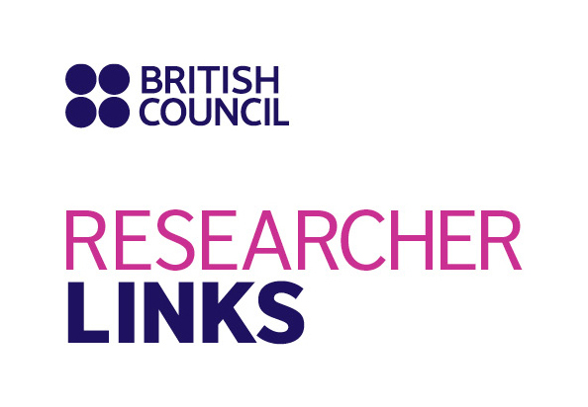

Application Form

|  |  |
| --- | --- |
| **1. Applicant** | |
| Name and title |  |
| Gender(to monitor statistic participation – this will not be considered during assessment) |  |
| Position and institution |  |
| Postal address |  |
| Email |  |
| Phone number |  |
| Brief CV (academic career, publications, markers of esteem, and any other relevant information) – no more than 2 pages of A4 | Please append your CV to this application |

|  |
| --- |
| **Abstract -** Please give asummary of your area of research |
|  |

|  |
| --- |
| **3. Please describe your motivation to attend the workshop and how the workshop matches your professional development needs** |
|  |

|  |
| --- |
|  |

|  |
| --- |
| **4. Please describe the expected impact of your participation to the workshop on your personal and professional development, including your ability to work on an international level** |
|  |

|  |
| --- |
| **5. Please indicate how you will disseminate the outcomes of the workshops and the new knowledge/skills you have acquired** |
|  |

|  |  |  |  |
| --- | --- | --- | --- |
| **6. Workshops will take place in English as standard. Please indicate your ability to work and communicate in English (Note, translators may be provided if necessary)** | | | |
| Native speaker |  | Good |  |
| Excellent |  | Need support |  |

|  |
| --- |
| **7. Please use this space to give any additional information that you feel is relevant for the application.** |
|  |