**Application Form – information for applicants**

Researcher Links Workshop

Delivering sustainable economic development in resource - rich nations:

Ukrainian Crisis: Risks and Opportunities for Azerbaijan as

an energy supplier and for its sustainable development

UK coordinator: Professor Yelena Kalyuzhnova (University of Reading)

Azerbaijan coordinator: Professor Ingilab Ahmadov (Khazar University)

Discipline: Economics (Energy Economics, Public Finance)

**Dates and venue: 16-19th February, 2015, Khazar University, Baku, Azerbaijan.**

The British Council has launched a new five-year programme to encourage international research collaboration between ambitious young researchers from the UK and eighteen countries around the world.

The programme, ‘British Council Researcher Links’ provides opportunities for early career researchers from the UK and internationally to interact, learn from each other and explore opportunities for building long-lasting research collaborations.

As part of this programme, a ‘call to action’ was issued in June 2013 for leading researchers to propose themes for bilateral workshops to be held in one of these countries which will bring together early career researchers to discuss their research and start to build international relationships.

Successful applicant organisations from the UK, University of Reading and Azerbaijan, Khazar University are now recruiting early career researchers and welcome applications to attend the above workshop.

The workshop will provide a unique opportunity for sharing research expertise and networking. During the workshops early career researchers will have the opportunity to present their research in the forms of a poster/short oral presentation and discuss this with established researchers from the UK and partner countries. There will be a focus on building up links for future collaborations and participants selected on the basis of their research potential and ability to build longer term links.

According to the terms of the project participants will have a chance to submit their research papers in refereed journals.

In addition, the Henley Business School (The University of Reading) is providing one PhD scholarship (tuition waver) for a one young researcher from Azerbaijan (subject of meeting all academic and English requirements)

The British Council will cover the costs related to the participation to the workshop, including: travel (both international and local), accommodation and meals. These costs include local visits included in the programme. Costs for the visa will be covered; however participants will be responsible for making all the necessary arrangements. Although this cost will not be covered by the British Council, participants are encouraged to purchase an adequate travel and medical insurance. The British Council accepts no responsibility for any problems which may occur when the participants are in-country.

**Workshop Aims and Outline:**

This workshop seeks to bring together world-leading researchers, early career researchers and locally-based policy-makers to share knowledge and understanding about the sustainable development achievement problems in resource rich countries, considering the case of Azerbaijan.

The workshop will focus on developing capacity at two levels:

*Capacity building for the local researchers* – sharing international knowledge and skills with invited promising researchers to improve their research capacity to create internationally recognised research work.

*Capacity building in relation to knowledge and skills improving petroleum governance practice in Azerbaijan through relevant recommendation package for decision makers* – it's expected to build a capacity for the local researchers and invited policy makers in the petroleum governance field to promote improvement of macro economy governance model in Azerbaijan.

The workshop will include keynote presentations from each of the leading academics. These will focus on recent thinking from both the UK and Azerbaijan, and also draw on wider international research. There will also be varied opportunities for debate and networking – with both a focus on substantive issues, and academic career development.

Local policy input will be provided by State Oil Fund of Azerbaijan (SOFAZ) and State Oil Company of Azerbaijan (SOCAR) and there will be an opportunity to develop a deep understanding of current country petroleum governance model and ways of improvement of this policy.

The programme will include Sanghacal terminal and cultural visits in Baku.

Papers from the following research areas are invited:

* Global challenges for the resource-rich countries: international conflicts and the EU
* Resource -rich countries development models
* Azerbaijani petroleum governance model
* Macroeconomic policy framework for petroleum rich countries
* Azerbaijani macroeconomic model and specifics
* Political and economic governance and capacity building in the natural resource management
* Fiscal transparency and accountability
* Budgeting in petroleum rich countries
* Sustainable economic development through transparency in resource rich countries
* Sovereign Welfare Funds: Global challenges

**Application and Deadline:**

The full application below must be completed and submitted by the **20thJanuary 2015** to: Professor Yelena Kalyuzhnova (y.kalyuzhnova@henley.ac.uk) for the UK applicants and to Professor Ingilab Ahmadov (ingilab@khazar.org) for Azerbaijani applicants - please place ‘Researcher Links Application’ in the title of the email.

**Eligibility Criteria:**

* Applications must be submitted using the Researcher Links application form
* Application must be submitted before the above deadline

Participants must be early career researchers: Early Career Researchers are defined as holding a PhD (or having equivalent research experience) – and having up to 10 years post-PhD research experience. They are equivalent to the ‘Recognised Researcher’ and sometimes ‘Experienced Researcher’ categories in the EU framework for researchers’ careers. <http://ec.europa.eu/euraxess/pdf/research_policies/Towards_a_European_Framework_for_Research_Careers_final.pdf>. Leading Researchers as defined by the EU Framework for researchers careers are research group leaders who are internationally recognised in their field.

* Participants must have a research or academic position (either a permanent post, research contract, or fellowship etc) at a recognised research institution either in the UK or in Azerbaijan.

**Quality Assessment**

* Experience and relevance of the applicant’s research area to the workshop
* Motivation and contribution to the aims of the workshop
* Description of the long term impact expected through the participation in the workshop
* Ability to disseminate workshop’s outcomes

**Selection Procedure:**

* Eligibility check
* Quality assessment

**Notification of results:**

Applicants will be notified by email in the last week of January, 2015.

**Equal Opportunities**

The British Council is committed to equal opportunities and diversity in all its activities and this includes the avoidance of any bias in the assessment of applications due to gender, disability, racial or ethnic origin, sexual orientation, or religious belief. Participants’ selection undertaken by workshop organisers must not contravene this policy. Extra support to enable participation of early career researchers with special needs will be given.

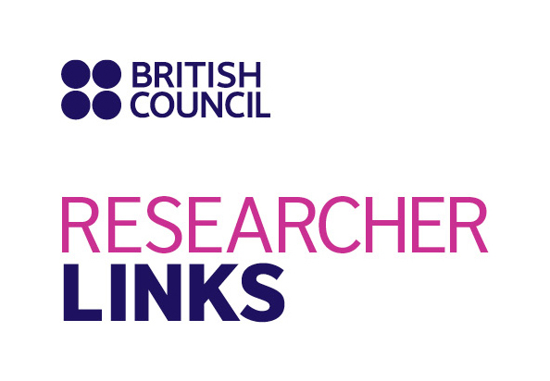

Application Form

|  |  |
| --- | --- |
| **1. Applicant** | |
| Name and title |  |
| Gender(to monitor statistic participation – this will not be considered during assessment) |  |
| Position and institution |  |
| Postal address |  |
| Email |  |
| Phone number |  |
| Brief CV (academic career, publications, markers of esteem, and any other relevant information) – no more than 2 pages of A4 | Please append your CV to this application |

|  |
| --- |
| **Abstract -** Please give a summary of your area of research |
|  |

|  |
| --- |
| **3. Please describe your motivation to attend the workshop and how the workshop matches your professional development needs** |
|  |

|  |
| --- |
|  |

|  |
| --- |
| **4. Please describe the expected impact of your participation to the workshop on your personal and professional development, including your ability to work on an international level** |
|  |

|  |
| --- |
| **5. Please indicate how you will disseminate the outcomes of the workshops and the new knowledge/skills you have acquired** |
|  |

|  |  |  |  |
| --- | --- | --- | --- |
| **6. Workshops will take place in English as standard. Please indicate your ability to work and communicate in English (Note, translators may be provided if necessary)** | | | |
| Native speaker |  | Good |  |
| Excellent |  | Need support |  |

|  |
| --- |
| **7. Please use this space to give any additional information that you feel is relevant for the application.** |
|  |